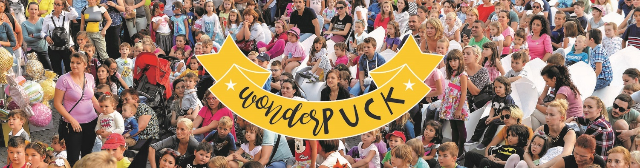
WonderPUCK Street Festival
Third edition

Cluj-Napoca, Romania
13th-15th September 2019

WonderPUCK Street Festival, a cultural event aimed for the entire family, with focus on children and teenagers, gets ready for its 3rd edition in September 2019!

The festival is an open-air cultural event, which gathers artistic domains such as theatre, dance, visual arts and handcrafts. Being a young festival, which started in 2017, it grew in the past few years, becoming the only festival dedicated to children and family in Transylvania.

Throughout the universal language of the artistic activities, the audience is invited to participate to these three days full of exceptional cultural experiences.

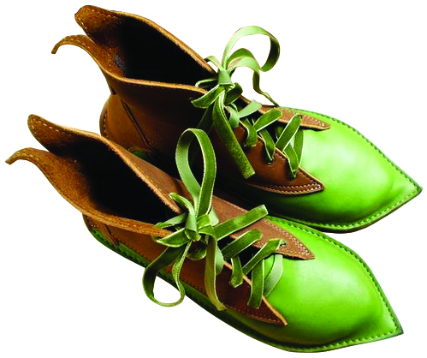
The access is free!

The structure of WonderPUCK Street Festival

As we have mentioned before, our festival has a complex program, combining artistic, educational and entertaining activities addressed mainly to young audiences. Throughout the three days of the festival, we will host:

- theatre performances for children and the entire family;
- creative workshops;
- street performances (with giant puppets, circus and carnival elements included);
- concerts;
- open-air exhibitions.

How to apply

If you are interested in our festival and you want to apply with a performance, a workshop proposal or an exhibition, please send the following materials to wonderpuckfestival@gmail.com email address:

- The Application Form;
- 3-4 photos that are representative for your performance or activity;
- A full video recording of your performance;
- The technical form of your performance (or the technical requirements, in case you are applying with a workshop or exhibition proposal).

Other issues

WonderPUCK Street Festival is not a competitive festival!

The performances, concerts, workshops, and exhibitions that are especially designed (or can be easily adapted) for open spaces will have an advantage in the selection process.

Timetable of the festival

- The festival time period: 13th-15th September

- Deadline for applications: until 15th February 2019

- Announcement of the selected performances/artists/activities: 1st April 2019

Organizational structure of the festival

WonderPUCK Street Festival is organised in collaboration with PUCK Puppet Theatre, ESUA Association and LIONS International Foundation. It also has the support of Cluj County Council together with Cluj-Napoca City Hall. Other companies, associations and non-profit organizations are welcomed as partners and co-organizers of the event.

PUCK PUPPET THEATRE
23 I.C. Brătianu st., Cluj-Napoca, Romania
Tel./fax: 004 0264 595 992
e-mail: teatrulpuck@yahoo.com
www.teatrulpuck.ro

